|  |
| --- |
|  |
| Monetary Policy |
|  |
| A tug of war between Inflation Control and Growth |

**Submitted to: mrs. dipti sharma**

April 7, 2017

A report by: Arpit Kumawat (2015ucp1524), Rohit Deegwal(2015ucp1542)

Table of Contents

1. **Introduction2**
2. **Why monetary policy2**
3. **objectives of monetary policy2**
4. **significance3**
5. **money supply3**
6. **inflation5**
7. **inflation rate over years6**
8. **types of monetary policies6**
9. **inflation control v/s growth7**
   1. **cash reserve ratio**
   2. **statuory liquidity ratio**
   3. **repo rate**
   4. **reverse repo rate**
   5. **bank rate**
   6. **open market operations**
   7. **marginal standing facility**
10. **15 Conclusion………………………………………………………**
11. **16 bibliography**

Monetary Policy

A tug of war between Inflation Control and Growth

### Introduction

It is a process by which the monetary authority of a country i.e. Central / Federal bank controls:

* Supply of money
* Availability of money
* And the cost of money i.e. the rates of interest on borrowing and lending.

### Why monetary policy?

The authority does so in order to attain certain predefined objectives oriented towards growth, development and stability of the economy.

### Objectives of Monetary policy

* **High Employment -:** High employment has been ranked among the foremost objectives of monetary policy. It is an important goal not only because unemployment leads to wastage of potential output, but also because of the loss of social standing and self-respect. High employment also ensures reduction of under utilization of capacity.
* **Price Stability -:** One of the objectives of monetary policy is to stabilise the price level by controlling inflation and deflation. Both economists and laymen favour this policy because fluctuations in prices bring uncertainty and instability to the economy.
* **Economic Growth -:** One of the most important objectives of monetary policy in recent years has been the rapid economic growth of an economy. Economic growth is defined as “the process whereby the real per capita income of a country increases over a long period of time.”
* **Foreign Exchange stability-:** Another objective of monetary policy has been to maintain equilibrium in the balance of payments i.e. a balance in the transactions between resident of the country and rest of the world during a period
* **Financial Market Stability-:** Markets go through booms and recession. These policies act as barriers to extreme recession and hence we can plan businesses and also plan future market strategies.
* **Interest Rate Stability -:** The interest rates such as the rates on bank loans, savings and deposits are managed through these policies and hence they maintain the stability of economy.

### Significance

The monetary policy are analogous to the human heart, regulating the money supply for prosperous functioning and growth the nation as human heart regulates blood supply keeping the person healthy

Monetary policy is concerned with changing the supply of money stock and rate of interest for the purpose of stabilizing the economy at full-employment or potential output level by influencing the level of aggregate demand.

### Money Supply

Money supply is the total physical and liquid assets flowing or circulating in an economy.

A liquid asset is cash on hand or an asset that can be readily converted to cash. An asset that can readily be converted into cash is similar to cash itself because the asset can be sold with little impact on its value.

The various types of money in the money supply are generally classified as Ms, such as M0, M1, M2 and M3, according to the liquidity factor. M0 contains the most liquid assets and M4 contains the non-liquid assets.

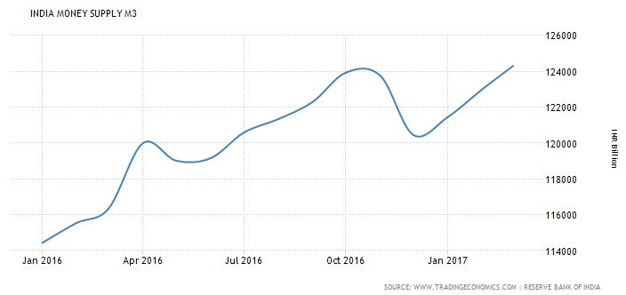

The above graph shows the money flow in the year 2016-17, the money flow increases and decreases several times to control the inflation and promote growth accordingly.

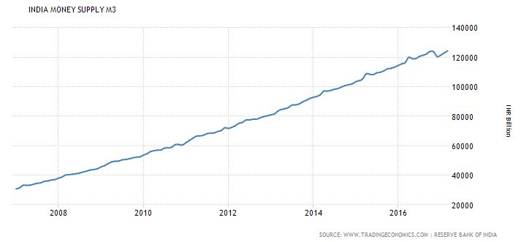

So, you may think that it is not constantly increasing and it should always increase to maintain growth.

And it does increases, if we see a wider view over the years as shown in the next graph the money supply increases almost linearly.

### What is inflation?

Inflation is the sustained increase in the price of a goods basket over a period of time.

The rise or fall in the inflation rate does not depend on the rise or fall of in the prices of particular commodity. Rather, it is an aggregate concept.

The Inflation rate is calculated over a basket of goods as the following picture depicts. Their weightings are also given in the image.

A 2% to 4% inflation rate is good for the healthy growth of economy.

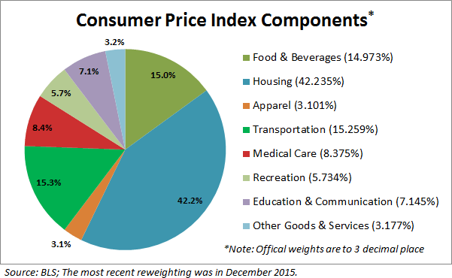

### Inflation rate over years

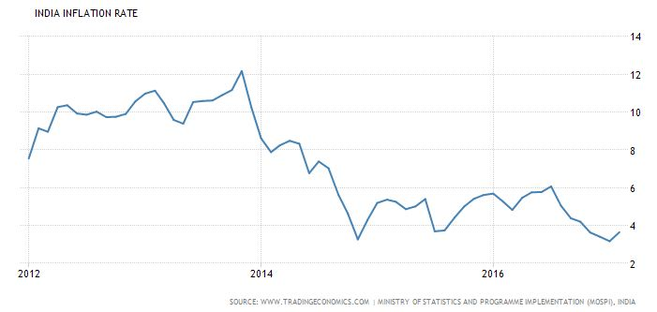

Current inflation rate is 3.65%.

### Types of Monetary policy

**Expansionary policies:** These policies are implemented when the money supply in the market is less.

Expansionary policy is traditionally used to try to combat unemployment in a recession by increasing the money supply by lowering interest rates in the hope that easy credit will entice businesses into expanding (creating aggregate demand).

**Contractionary policies:** These policies are implemented when the money supply in the market is more.

Contractionary policy is intended to slow inflation in order to avoid the resulting distortions and deterioration of asset values.

Creates a slow down in the growth rate of the economy to prevent it from overheating.

### Inflation Control v/s Growth

The rationality is that the two main objectives of Monetary policies i.e. Inflation Control (Price stability) and economic growth are conflicting ones.

So, if one monetary policy tends to control inflation then it will be at the cost of growth and if one wants rapid growth then inflation follows it.

To have a clear view of the dilemma, we will now see some of the instruments of Monetary Policy using which stability is achieved with a parallel discussion on the impact of these tools on inflation control and growth.

#### Cash Reserve Ratio

Cash Reserve Ratio is a certain percentage of bank deposits which banks are required to keep with RBI in the form of reserves or balances (as cash).

Higher the CRR with the RBI lower will be the liquidity in the system. Hence, Inflation is controlled.

In case when CRR is low, banks will deposit less, more liquidity in economy, people have more to spend and growth follows.

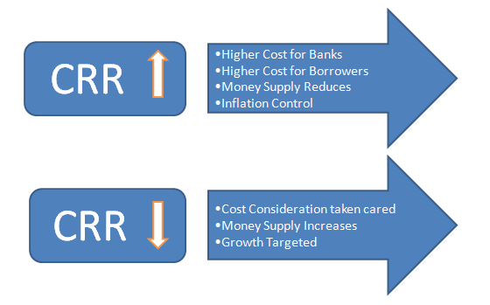

#### Statutory Liquidity Ratio (SLR) and Its Impact

The Commercial and domestic banks need to maintain an amount of total deposit as securities and bonds with it. The ratio is decided by RBI.

The impact is the following:-

It is the Indian government term for reserve requirement that the commercial banks in India require to maintain in the form of gold, government approved securities before providing credit to the customers.

As the SLR increases the liquidity of money in market decreases and Inflation is controlled since the bank will have less to lend and money spending of citizens’ decrease and money supply also decreases.

Reverse scenario is explained by the image below.

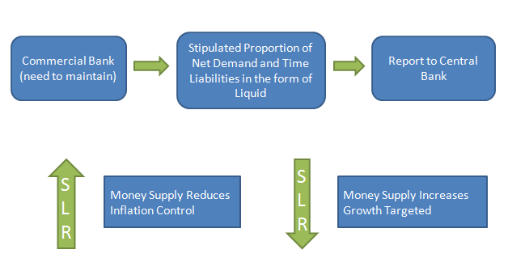

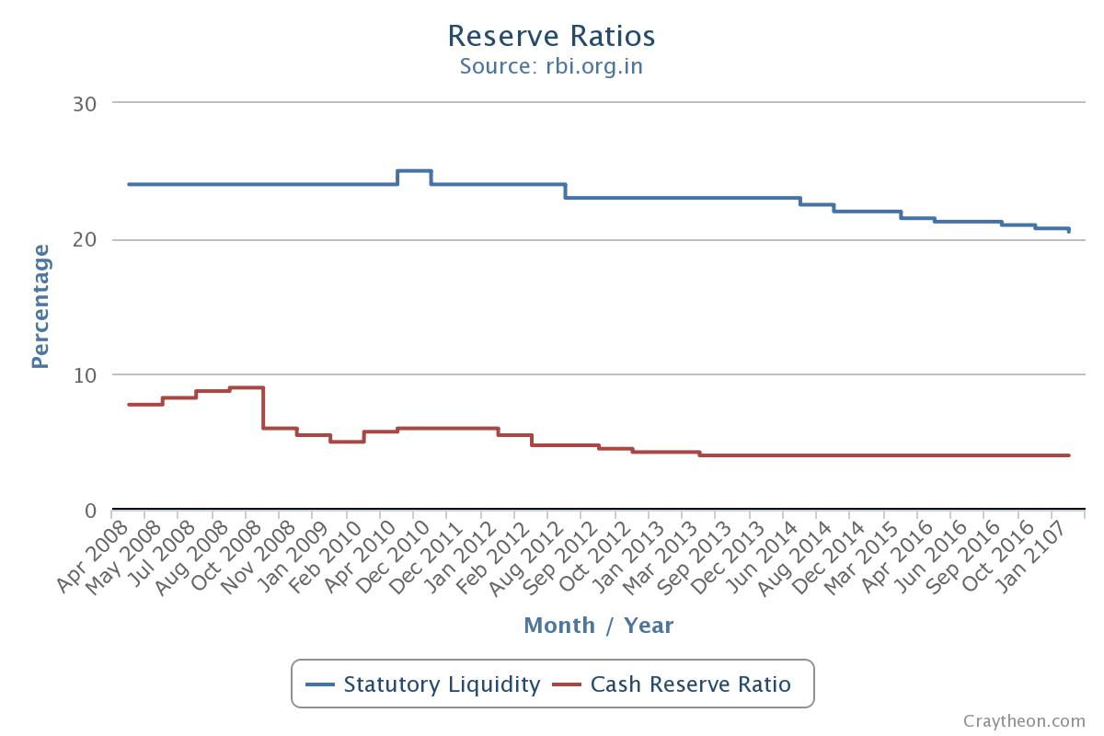

The graph shows SLR and CRR over the recent years.

It shows that SLR is decreasing over the years which increase the money supply in economy and thus promotes growth.

We can also observe that the CRR is maintained constant over the recent years.

#### Repo Rate (short term)

It is the rate at which the central bank lends money to the Commercial banks at times of shortfall.

If the Repo rates are high the interest to be paid is high and also they may borrow less, this decreases the money supply and controls inflation.

The other scenario is shown in the image below:

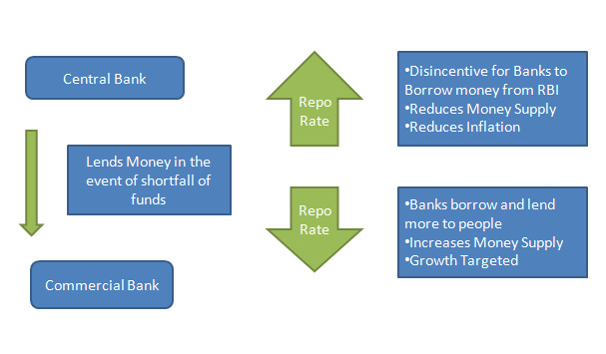

#### Reverse Repo rate

Reverse Repo rate is the rate at which RBI borrows money from the commercial banks.

The increase in the Reverse Repo rate will increase the cost of borrowing and lending of the banks which will discourage the public to borrow money and will encourage them to deposit.This leads to the decrease in the currency circulation in the economy and inflation is controlled.

Whereas, if the Reverse Repo Rate decreases the commercial banks will lend less to the RBI since the Reverse Repo Rate is low and they will lend more to the people and hence this will increase the money supply and growth follows.

#### 

#### Variation of the RRR and RR in the recent years

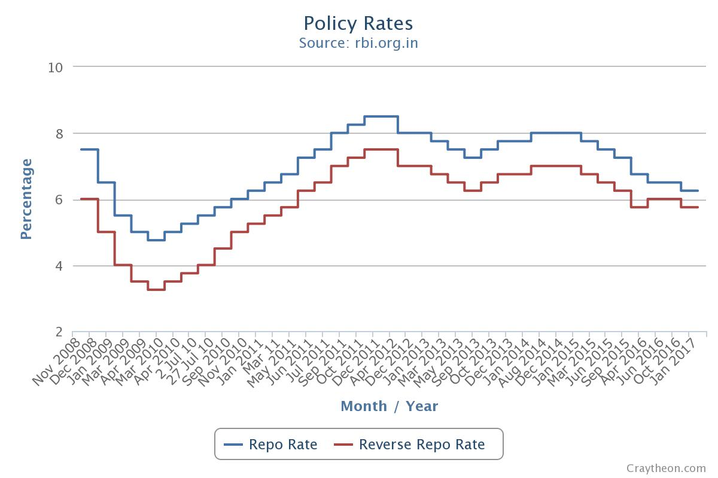

#### Bank Rate (long term)

It is the rate at which the RBI lends money to the Commercial and domestic banks.

The impact of the increase or decrease in this rate is explained by the image below:

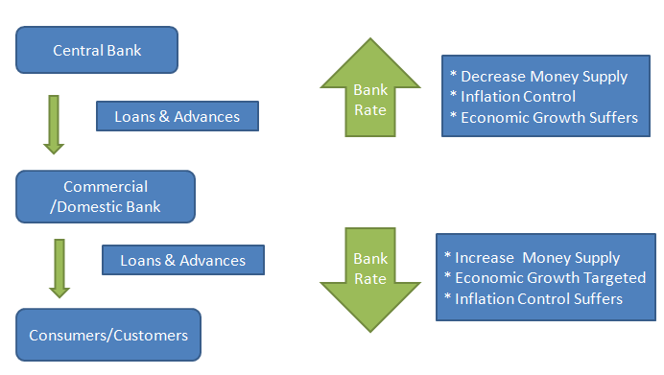

#### Open market Operations

These include buying and selling of government securities by the Reserve Bank on secondary markets.

These include both outright purchase/sale of government securities for injection/absorption of durable liquidity, respectively.

As mentioned above the operations follow two pathways.

**Firstly**, when there is an excess in supply of money in the economy.

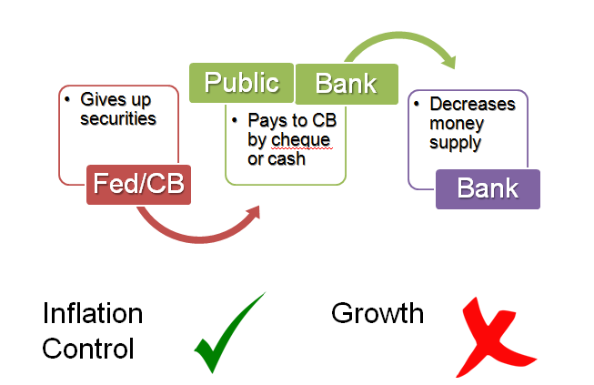

The RBI issues securities and bonds to the people and the commercial banks on which they are paid some interest amount. The RBI takes up the money which decreases the money supply in the hands of the people. This leads to Inflation control.

**Secondly,** when there is less supply of money in the economy.

Public and banks give up the securities with them and the RBI pays back so that the spending of the economy increases with the increase in the supply of money, which promotes growth.

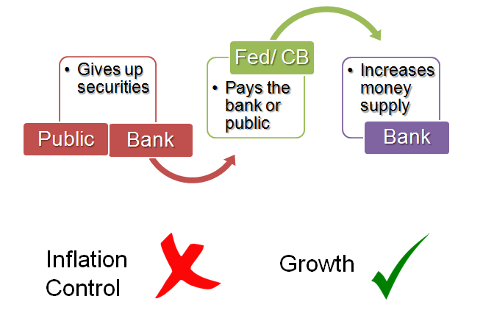

#### Marginal Standing Facility

* Marginal Standing Facility is a new Liquidity Adjustment Facility (LAF) window created by RBI in its credit policy of May 2011.
* MSF is the rate at which the banks are able to borrow overnight funds from RBI against the approved government securities.
* The amount depends on their Statutory Liquidity Ratio (SLR) portfolio up to a limit (currently two per cent of their net demand and time liabilities deposits) at a penal rate of interest.
* **The question is** – Banks are already able to borrow from RBI via Repo Rate and bank rate then why MSF is needed?

Through this facility the commercial banks can borrow money from the RBI overnight under certain emergency conditions at rates slightly higher than the repo rate.

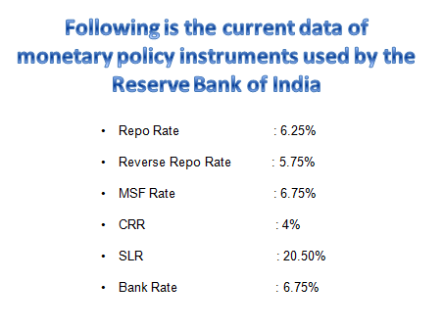

### Conclusion

So, it is clear from the above discussion that inflation control and growth are like the two faces of the coin.

That is, one can only be achieved at the expanse of another.

If one monetary policy tends to control inflation then growth will suffer and if monetary policy tends to increase economic growth then inflation will follow.

Even in our country RBI likes to avoid rate cuts and control inflation, whereas, the central government like to cut rates and promote economic growth.

### Bibliography

* www.rbi.org.in
* www.wikipedia.org
* www.craytheon.com
* www.tradingeconomics.com